Keepass advanced usage:

What is this about: automation; macroing frequently used commands (like logins)

1# keybind your terminal:

computer → control center → [Personal] Keyboard Shortcuts:

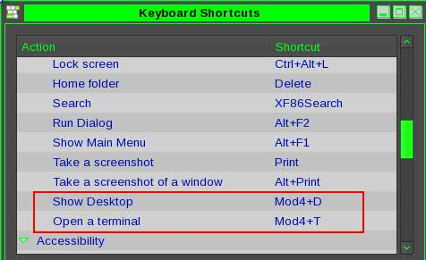

I have these two which I find to be very useful;   
 Show Desktop: [windows button+D] shows/hides Desktop – useful when many apps are opened.

Open Terminal: [windows button+T] opens default terminal window

2# set up terminal profiles

a; Open terminal: File → New Profile..

or Edit → Profiles

b; New: <name> (I suggest naming the same in both [General] and [Title and Command] tabs.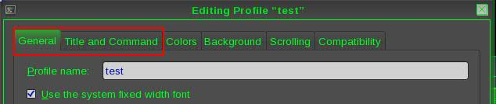

If you wish to connect to a specific server you can type a custom command to the [custom command] field.

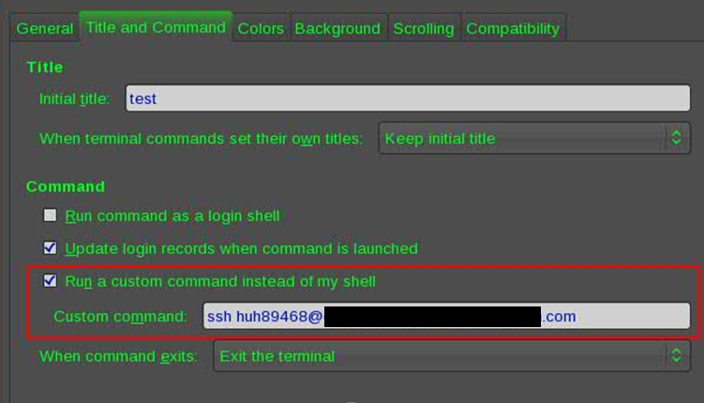

One more thing: Put a tick to unlimited scrolling:

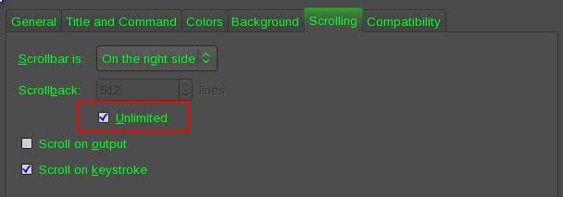

Set up **KeePass**:

1# New Entry:

-save your passwd

**Enable Autotype and customize your target window:**

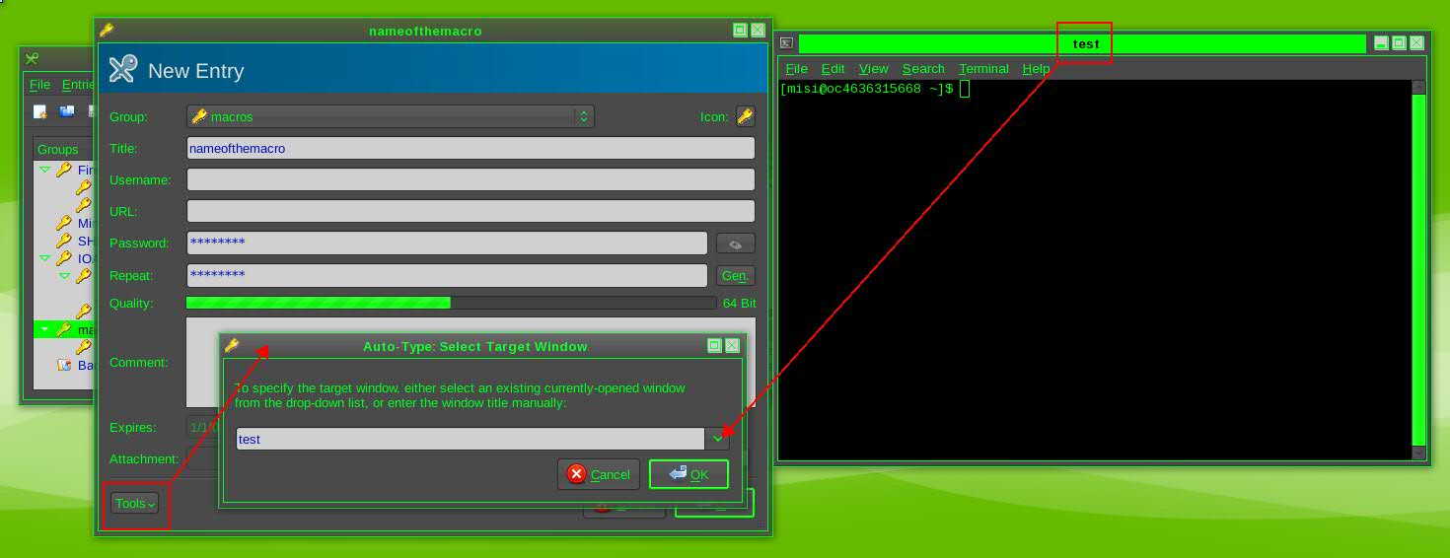 **^**click tools → Auto-Type selected window → select the terminal with the correct name.   
(note: the terminal or web page or whatever application you are setting the keepass to.. should be opened in order to be able to select it from the list)

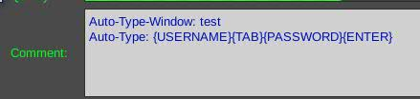Now click Tools again: select Auto Type:

This is how it looks like in default.

If you are using ssh like in in the example at “test” terminal then delete the {USERNAME}{TAB}

Now if you wish you can customize db2 logins; scp; weekly reports and almost anything...

For example this is my SCP macro:

Auto-Type-Window: DanPI_SCP_dwn

Auto-Type: ssh huh89468@[IP of the jump server]{ENTER}{DELAY 3000}{PASSWORD}{ENTER}scp scadmin@[IP of the target server]:/tmp/{USERNAME} /tmp{ENTER}{DELAY 3000}[pw of the scadmin in text]{ENTER}{DELAY 10000}logout{ENTER}{DELAY 100}scp huh89468@[IP of the jump server]:/tmp/{USERNAME} /home/misi{ENTER}{DELAY 3000}{PASSWORD}{ENTER}

note: text between [] brackets should be totally replaced with the IP only (in those 3 cases here)  
 For example: ssh [huh89468@198.168.0.1](mailto:huh89468@198.168.0.1){ENTER}....

I used here the {USERNAME} as variable. So each time before I take the file that I copied to /tmp in command line I copy the filename to my Keepass – username field:

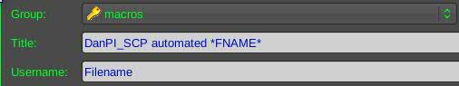

max delay is 10000 which = to 10 sec. (you can set more delays after each other with 10 sec tho)

Here is a list of buttons – how the syntax should be in KeePass: **http://keepass.info/help/base/autotype.html**